MAG LEVEL 4 FLOOR (1)
Fwd Roll | 1. ®© Fwd Roll Lunge | 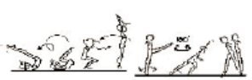
  - Forward roll to stand with arms vertical. Step forward to momentary lunge, 180º turn backward, bringing feet together and arms to horizontal.
 | 2. ®* Fwd Roll Headspring Lunge | 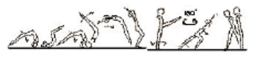
  - Forward roll, headspring to stand with arms vertical. Step forward to momentary lunge, 180º turn backward, bringing feet together and arms to horizontal.
Handstand (for walkover, handspring and flic flac) | 1. Handstand with nose against wall – looking at hands – covering ears, hips open, bottom squeezed. Push “tall” up the wall – 1 min | 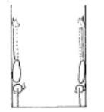 | - arms straight  - chest rounded, extended through the shoulders  - hips open  - gluteal muscles squeezed  - head neutral  - maintain good body tension and alignment  - toes or heels touch the wall only
 | 2. Handstand against horse | 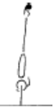 | - arms straight  - chest rounded, extended through the shoulders  - hips open  - gluteal muscles squeezed  - head neutral  - maintain good body tension and alignment
 | 3. Handstand on parrallettes
 | 4. F2-1.9 Handstand 360’ or more
Handstand Fwd Roll | 1. ®© Handstand Fwd Roll Straight Jump | 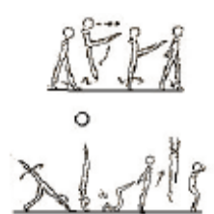
  - Take one step forward (at least hip height) to scissor kick, step with left leg to momentary handstand, forward roll immediate straight jump.
 | 2. Handstand “pop” fwd roll
 | 3. F3-2.5 Handstand ½ turn fwd roll – turning the “inside” hand first – then the outside hand | 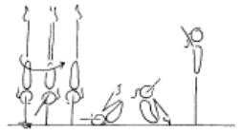 | - maintain good body tension and alignment  - place body weight onto right hand, maintaining  - the centre of gravity over the base of support  - turn the whole body as one unit  - head neutral  - extend through the shoulders prior to rolling  - encourage a straight body during the early phase of the fall  - roll in a tight tuck and stand to finish
Cartwheel / Roundoff | 1. © Cartwheel, cartwheel | 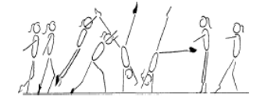 | - start with square hips and shoulders in the direction of travel  - lunge into the cartwheel maintaining square posture  - kick to a vertical side handstand with a small straddle  - first hand is placed same as a side cartwheel and becomes the support and rotational hand  - second hand is turned a 1/4 turn and placed pointing towards the first hand and becomes the repulsion hand  - head neutral  - body rotates 1/4 turn so that shoulders and hips are now square and facing the direction of travel  - head is neutral and eyes can see where the foot is about to land  - keep arms straight and chest in  - once the body is vertical over the second hand the chest lifts and the feet come down causing a ‘see-saw’ illusion  - the shoulders must not go past the vertical line  - finish in a stand with arms forward low horizontal  - chest in, hips open
 | 2. F4-2.5 Perform a roundoff from a rebound surface to a lower landing surface – to back | 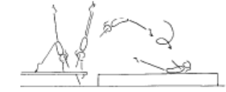 | - ensure the body remains within the vertical plain, no pike or arch action  - maintain good body tension and alignment  - repulsion from hands occurs during the vertical phase when the body is travelling upwards with the heel drive  - land in a dish shape with arms forward low horizontal

MAG LEVEL 4 FLOOR (2)
Cartwheel / Roundoff con’t | 3. Roundoff rebound | 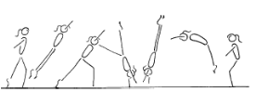 | - start with square hips and shoulders in the direction of travel  - lunge into the round off maintaining square posture  - kick to a vertical position  - first hand is placed same as a side cartwheel and becomes the support and rotational hand  - second hand is turned a ¼ turn and placed pointing towards the first hand and becomes the repulsion hand  - gymnast must be in line with the first hand  - head neutral  - body rotates ¼ turn so that shoulders and hips are now square and facing the direction of travel  - head is neutral and eyes can see where the feet are about to land  - keep arms straight and chest in  - once the body is vertical over the second hand the chest lifts and the feet come down causing a ‘see-saw’ illusion  - the shoulders must not go past the vertical line  - finish in a rebound with arms forward low horizontal  - chest in, hips open
 | 4. ®© Scale, Cartwheel ¼ turn, Roundoff | 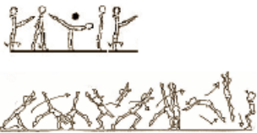
  - Lift leg backward to scale (hold 2 secs). Lower leg to stand, high step fwd to cartwheel ¼ turn immediate Round Off Straight Jump to Stand.
Backward Roll (for back salto) | 1. F2-4.6 Back extension roll to front support on raised surface, gradually build the height | 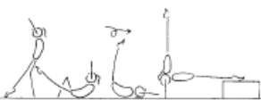 | - maintain body tension and alignment  - head neutral
 | 2. F2-4.5 Back extension roll down an incline to handstand with straight arms (then on the floor) | 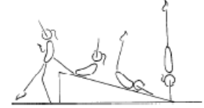 | - maintain body tension and alignment  - head neutral
 | 3. Backward extension roll to handstand | 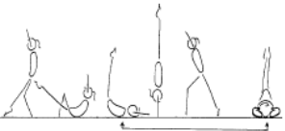 | - start position can vary  - smooth rotation and rhythm  - head starts neutral  - as roll commences the chin tucks onto the chest, then returns to neutral after the roll  - hands are placed on the floor early by hips then when weight has passed over the hands they move immediately to beside the head  - at the same time as the arms push the hips should extend quickly to assist the rotation  - finish position can vary
Turns | 1. ® © Jump with 1/1 turn | 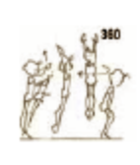
  - Jump vertically with 1/1 turn to stand.
FWO, BWO & Tic Toc | 1. Limber from stand – down to bridge and up again
 | 2. F2-5.7 Bridge from standing kickover to stand (back limber) | 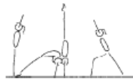 | - keep hips in line with feet  - stretch up first then open shoulders to initiate the bridge  - keep gluteal muscles tight  - maintain good body tension and alignment  - legs straight in the kick over (legs can be together – advanced, or in split)
 | 3. F2-5.8 Kick to handstand into a bridge, stand (front limber) | 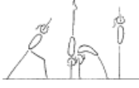 | - keep hips in line with hands during the handstand  - support phase  - stretch up first then open shoulders to initiate the bridge  - keep gluteal muscles tight  - maintain good body tension and alignment  - head neutral  - use the muscles in the legs and hips to stand
 | 3. Fwd or bwd walkover or  Tic Toc or  Backward roll to front support | 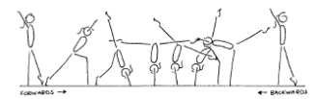  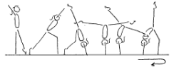 | - arms beside ears during all phases of the skill, with eyes looking at hands  - front walkover and tic-toc must pass through a vertical handstand prior to opening the shoulder angle to  - allow the bridge to occur (back walkover must start in a vertical stand before going back into the bridge phase)  - 180’ split of legs during the skill  - keep back and/or front legs still during scale phase  - arms straight, thumbs parallel and together  - the bridge action uses the hip and shoulder flexibility  - maintain good body tension and alignment  - square hips and shoulders throughout the skill

MAG LEVEL 4 FLOOR (3)
Handspring | 1. From a standing hurdle off beatboard, perform a front handspring to 2 feet – to a soft landing mat
 | 2. F4-4.3 perform a front handspring from a run hurdle using a rebound or raised surface (bench), to a soft landing mat | 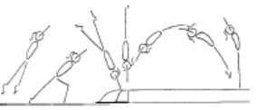 | - maintain good body tension and alignment  - repulsion from hands occurs when the body is 3aximize3 upwards with the heel drive  - land in an arch shape with arms by ears  - head neutral with eyes looking at hands
 | 3. F4-4.4 Same as F4-4.3 with a shape in front of the bench to force the gymnast to go up | 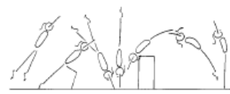 | - maintain good body tension and alignment  - repulsion from hands occurs when the body is 3aximize3 upwards with the heel drive  - land in an arch shape with arms by ears  - head neutral with eyes looking at hands
 | 4. ®© Handspring, Splitz, Rear Support, Front Support, Stand | 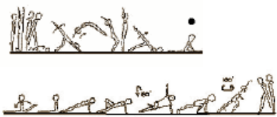
  - Three (3) steps hurdle handspring, fall to prone, with one leg raised. Circle raised leg around with 180º turn to splits (hold 2 secs). Move rear leg around to sitting position. Lift hips to rear support, raise one leg, bend knee and turn 180º to front support with forward leg bent. Stand upright with 180º turn.
Flic Flac | 1. F4-3.5 Flic Flac on a padded box, hands land on the box, feet land on the supersoft mat | 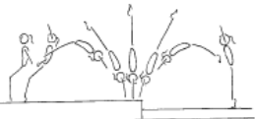 | - maintain body tension and alignment  - head neutral  - hands slightly turned in on contact  - emphasis initial starting and finishing position
 | 2. F4-3.6 Flic flac down inclined soft mat | 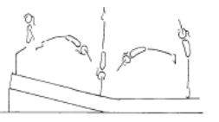 | - maintain body tension and alignment  - head neutral  - hands slightly turned in on contact  - emphasise initial starting and finishing position
 | 3. F4-3.7 Flic flac on a trampoline | 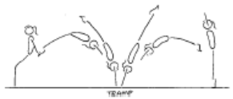 | - maintain body tension and alignment  - head neutral  - hands slightly turned in on contact  - efficient forward and backward body snap action
 | 4. F4-3.8 Flic Flac off a mini tramp or double mini tramp | 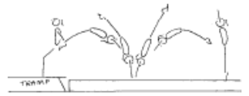 | - maintain body tension and alignment  - head neutral  - hands slightly turned in on contact  - efficient forward and backward body snap action
 | 5. F4-3.9 Flic Flac onto a raised surface – to overload the jump (land on feet or stomach) | 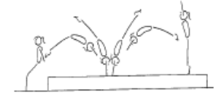 | - maintain body tension and alignment  - head neutral  - hands slightly turned in on contact  - efficient forward and backward body snap action
 | 6. F4-3.10 From handstand on a box, snap down onto a mini tramp, immediate flic flac | 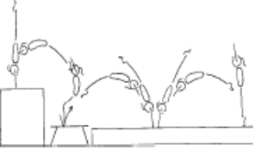 | - maintain body tension and alignment  - head neutral  - hands slightly turned in on contact  - efficient forward and backward body snap action
 | 7. Roundoff Flick | 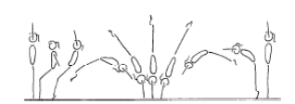 | - from initial starting position, the body starts moving backwards and body makes a smooth dish shape – chest in  - jump  - sequentially open hips, then open shoulders and arms in line with body (backward body snap)  - head neutral with eyes looking at hands  - land on hands in a smooth arch shape (open hips)  - rebound from hands to feet, forward body snap and strong push through hands, arms and shoulders  - a smooth landing with control and return to initial starting position

MAG LEVEL 4 FLOOR (4)
Back Salto | 1. F6-1.7 Step from raised surface to mini tramp, 2 feet jump fwds with a ¼ counter rotation bwds to land on flat back in straight position on raised crash mats | 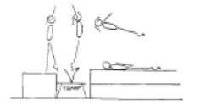 | - hips open  - shoulders open  - head straight between arms  - hips rotated under  - push hips forward  - arms close to thighs after feet leave mini-tramp
 | 2. F6-1.8 Snap down ¼ layout salto to back/shoulders | 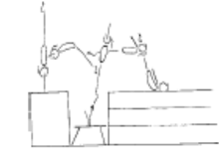 | - chest in  - hips open  - head neutral  - arms close towards body after feet leave the minitramp  - maintain body tension and alignment
 | 3. F6-1.9 ¾ Layout to stomach | 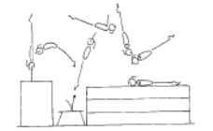 | - arms by side
 | 4. F6-1.10 Snap down straight body back salto | 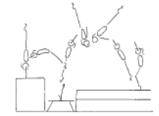 | - maintain good body tension and alignment  - fast rotation  - good height
 | 5. F6-1.11 Perform a roundoff flic flac rebound onto a raised surface | 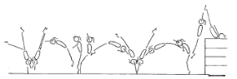

MAG LEVEL 4 HORIZONTAL BAR (1)
Hanging & Grip Strength | 1. ®© Lift to L Hang | 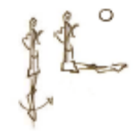
  - Lift legs to momentary L hang.
Front Support /Casts | 1. ® © Cast to free support | 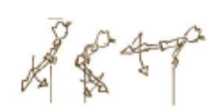
  - Cast to horizontal free support.
Back Hip circle | 1. ® © Backward hip circle | 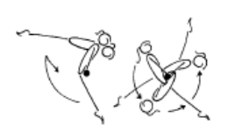 |  | - maintain good body tension and alignment  - arms straight  - head neutral  - after the cast the shoulders move backward whilst the feet move down, forward then upward  - push chest back  - rotation should be even and smooth  - wrists move quickly on completion of the circle  - finish in front support
Dismount | 1. ®© Underswing Dismount | 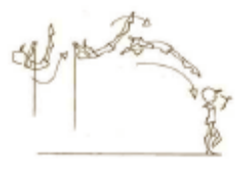
  - Underswing dismount forward to stand.
Back Hip Circle | 1. ®© Back hip circle | 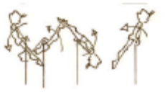
  - Backward hip circle.
Long Swings & Long Swing Pullover | 1. ®© Tension swings x 1 | 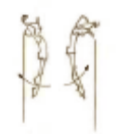
  - Tension swing backwards and forwards once.
 | 2. ®© Underswing, swing bwd & fwd x 2 | 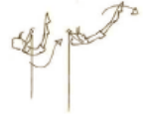 | 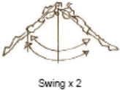
  - Pull through forward underswing.
  - Swing backwards and forwards two times.
 | 3. 3 x Tap swings on High bar (from kick start) | 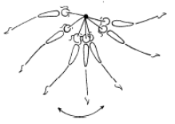 |  | - smooth rhythm  - swing should gain amplitude  - strong forward tap  - strong backward tap
 | 4. B4-5.1 Chin up pullovers x 10 | 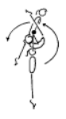 |  | - hips under, head neutral  - maintain good body tension and alignment
 | 5. 2 x long swings to long hang pullover on the 3rd swing | 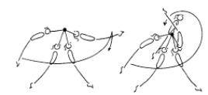 |  | - feet level with, or above, the low bar at the back of the swing  - chest in hips under, head neutral  - as the feet pass the low bar drive the heels back behind the bar and extend the hips  - pass through the vertical line in a slight arch shape  - powerful tap (forward body snap) to generate swing  - at the peak of the first forward swing the feet start to descend backward body snap will set up a powerful  - return swing  - repeat forward swing extend tap to circle body around the high bar  - finish in good front support

MAG LEVEL 4 HORIZONTAL BAR (2)
Kips | 1. B3-6.1 with two feet in a sling, swing kip to front support x 10
 | 2. 20 x Bum ups – on the ground
 | 3. Straddle leg lifts – hanging on a high bar. Show star, rotate hips under through straddle position and up to touch bar x 10
 | 4. Glide – snap toes to the bar & hold toes to the bar
 | 5. B4-3.4 – Drop kip (may be assisted) – used to develop strength in kip action and to improve the ‘rhythm’ of the skill | 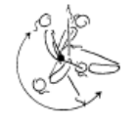 | - commence in a strong front support shape  - maintain shape during swing down  - keep arms locked  - bring the feet to the bar as the shoulders swing  - around the bar  - relaxed shoulders  - efficient kip action (hip extension)  - head neutral  - strong shoulder flexion then occurs  - move the wrists on top of the bar
 | 6. ®© Kip with assistance | 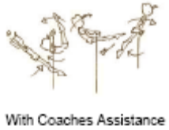
  - Kip with coach’s assistance to support.
 | 7. B4-3.4 Spotted glide kip, drop kip series x 5
 | 8. ®* Kip unassisted | 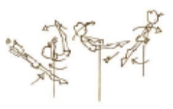
  - Kip without any coach’s assistance to support.
Cast to Handstand | 1. B4-4.1 Kick to handstand on a floor bar with assistance if necessary – begin with one foot on the bar
 | 2. B4-4.2 Front support flexion/extension activity with coach | 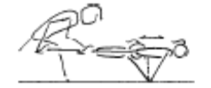 | - strong shoulder action  - chest in  - maintain body tension and alignment  - head neutral
 | 3. B4-4.3 Bounce to handstand using tyre | 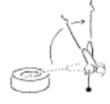 | - strong shoulder flexion  - shoulders forward of bar  - strong chest position  - awareness – demonstration of shoulder depression and extension; “push tall!”  - maintain body tension and alignment
 | 4. B4-4.5 From standing on a floor bar, jump straddle up to handstand | 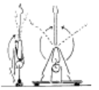 | - arms straight  - shoulders lean slightly over the bar at the start  - finish handstand with wrists, shoulders and hips in a vertical line  - legs straight and toes pointed  - straddle legs around the side
 | 5. B4-4.4 Cast to handstand – coach assisted, return to the bar in control | 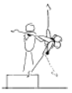 | - chest in  - shoulders forward  - fast heel drive and hip extension
 | 6. B4-4.7 From front support, cast to straddle with feet on 2 boxes, jump to straddle handstand

MAG LEVEL 4 VAULT (1)
Bounce /Spring | 1. Ankle raises x 20 with both feet then 15 on each leg
 | 2. V1-5 Springing Circuit – variety of 8 objects
 | 3. Skipping rope x 100
Hurdles | 1. Hurdles on board – correct arms
Catsprings –Handspring Vault | 1. “Blocks” onto 105cm table
 | 2. Handspring to flatback – mats same height as table | 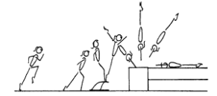 | - fast run  - low hurdle  - underarm action  - repulsion is instantaneous  - dynamic  - fast heel drive (backward body snap)  - hands contact vault early during the upward phase  - 7aximize air time in after flight  - good body tension throughout – legs straight and together, arms straight, head neutral
 | 3. V3-4.5 Long run handspring ‘pop’ onto a raised surface (3-4 supersoft mats) | 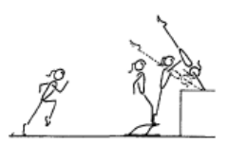 | - low hurdle – to 7aximize7e on speed generated in the run  - contact the board slightly leaning backwards with only minimal flexion of hips and knees  - circle arms down the sides to thrust vigorously  - forward and upwards so that hands contact the horse as early as possible during the ascent phase
 | 4. Handspring over 90cm box | 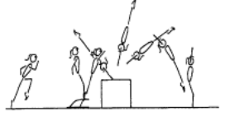 | - fast run  - low hurdle  - underarm action  - fast heel drive (backward body snap)  - hands contact box early during the ascent phase  - repulsion is instantaneous  - 7aximize air time in after flight  - maintain good body tension and alignment  - dynamic
Dive Roll / Front Salto | 1. Short run, hurdle with arm circle, tuck front salto to 60cm | 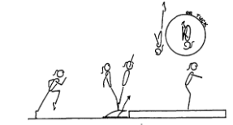 | - fast run  - low hurdle  - underarm action  - fast rotation  - maximum air time  - good body tension throughout  - dynamic  - shoulders travel vertical on take-off  - fast heel drive (backward body snap)  - on landing the hips, knees and ankles joints flex to absorb the landing
 | 2. ®© Tucked front salto over 90cm block to stand on mat | 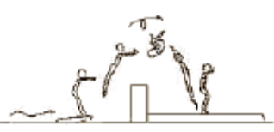
  - Tucked front salto over 90cm high block to stand on mat.
 | 2. V4-1.7 Jump from a box to a mini tramp or double mini, ¾ layout front salto onto 3 supersoft mats to land flat back | 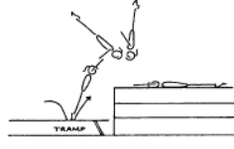 | - fast heel drive  - have slight arch throughout  - maintain good body tension and alignment

MAG LEVEL 4 POMMEL (1)
Front Support & Straddle Swings | ®© Straddle swing through front support | 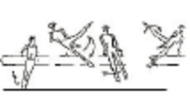
  - Jump through front support to swing to the right and to the left with legs apart.
Stride Supports & Swings | ®© Stride Swing L Leg Fwd | 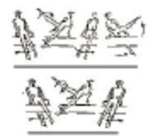
  - Swing both legs to the left and swing left leg in over the left handle. Swing in stride support to the right and back to the left, bringing left leg out over the left handle.
 | ®© Stride Swing R Leg Fwd | 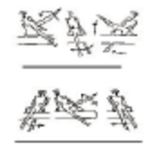
  - Swing through front support to the right, bringing right leg in over right handle. Swing through stride support to the left and back to the right. Swing right leg out over right handle.
False Scissors | ®© False Scissor to the Right | 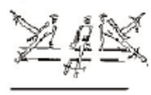
  - Swing left leg in over the left handle. Swing to the right in stride support bringing left leg out over the right pommel (false scissor).
Dismount | ®© Right leg over with 90’ Dismount | 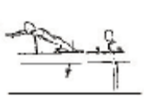
  - Swing to the right in stride support.
  - Swing right leg in over the right handle and dismount with 90º turn to the left.
 | ®* Pickup ½ Circle with 90’ counter turn dismount | 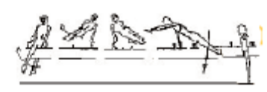
  - Swing in stride support to the right.
  - Swing right leg in over right handle and pick up a ½ double leg circle over left pommel and dismount with 90º counter turn to the right, replacing left hand on the saddle.

MAG LEVEL 4 MUSHROOM (1)
Circles | ®© 10 x circles – one at a time | 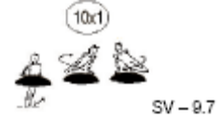
  - From stand, jump to ten double leg circles on mushroom.
 | ®* 10 x circles with at least 6 consecutive circles | 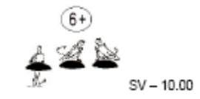
  - From stand, jump to ten double leg circles on mushroom with at least 6 circles performed consecutively
Dismount | ®© Dismount to stand | 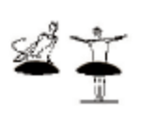
  - Dismount at back of circle to stand.

MAG LEVEL 4 RINGS (1)
Hangs | ®© Lift with bent arms, bent body and straight legs to inverted hang | 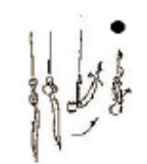
  - Pull with bent arms, bent body and straight legs to stretched inverted hang (2 secs).
Swings | ®© Cast to back swing | 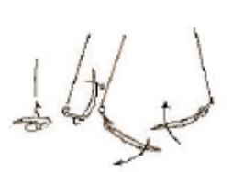
  - Lower legs to piked position and cast to swing backward.
 | ®© 2 x swings | 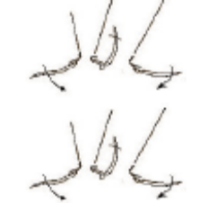
  - Swing forward and backward two times.
 | ®© Stretched inlocate to back swing | 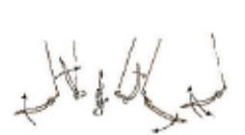
  - Inlocate with stretched body to inverted hang and swing backward.
 | ®* Stretched inlocate through inverted hang to back swing with continuous heel lead and no hesitation | 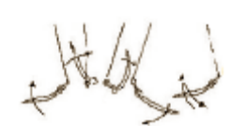
  - Inlocate with stretched body through inverted hang and swing backward.
 | ®© Swing to inverted hang | 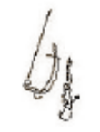
  - Swing forward to stretched inverted hang.
 | ®© Cast to ½ arm swing | 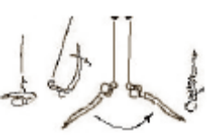
  - Lower legs to piked position and cast with bent arms to swing backward and forward in “chin up” position to stretched inverted hang
Dismounts | ®© Cast to swing bwd, swing fwd, to tucked back salto dismount | 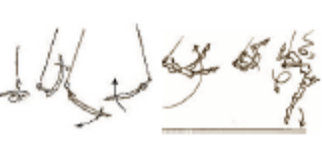
  - Lower legs to piked position and cast to swing backward. Swing forward directly into Tucked Back Salto Dismount.

MAG LEVEL 4 P BARS (1)
Mount | ®© Basket kip to straddle sit with coach assistance | 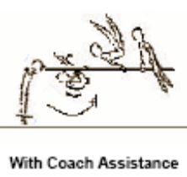
  - From stand jump to basket kip to straddle sit on Parallel Bars with coach assistance
 | ®* Basket kip to straddle sit without coach assistance | 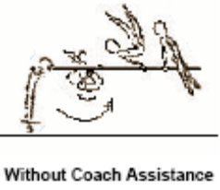
  - From stand jump to basket kip to straddle sit on Parallel Bars
Supports | ®© L sit – 2 secs | 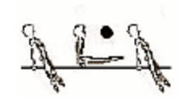
  - From straddle sit on Parallel Bars lift to L-Sit (Hold 2 sec). Straddle legs back to straddle sit on Parallel Bar
Rolls | ®© Press to shoulder balance & fwd roll to sit | 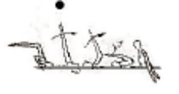
  - Place hands on the bars in front of the legs and press to shoulder balance (hold 2 secs). Lower legs to piked position and roll forward to straddle sit (hands behind the legs)
Swings | ®© Support swing bwd & fwd x 2 | 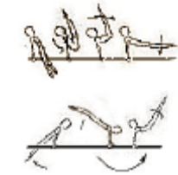
  - Raise legs off the bars toward V support and swing backward at least to horizontal and swing forward.
Dismounts | ©® Swing bwd to dismount over bar | 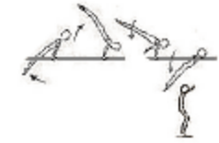
  - Swing backwards to 60º above horizontal and dismount over one bar to stand.

